**Group 16 : Nishita Shewale, Ritik Gupta, Siddharth Pawar, Sakshi Aade**

**Final Project: Data Profiling & Staging Report**

**Alteryx : Data Profiling Report (Part 1)  
Dataset :** [**https://data.austintexas.gov/Transportation-and-Mobility/Austin-Crash-Report-Data-Crash-Level-Records/y2wy-tgr5/about_data**](https://data.austintexas.gov/Transportation-and-Mobility/Austin-Crash-Report-Data-Crash-Level-Records/y2wy-tgr5/about_data)

**Description :** This dataset contains crash-level records for crashes which have occurred in the last ten years in Austin.

**Number of attributes : 54,**

**Record Count : 147750,**

**Tool used for concluding the above info : “Browse Tool” (this** tool is used to view the data at any point in the workflow, providing a quick and easy way to inspect the results of data transformations and manipulations)

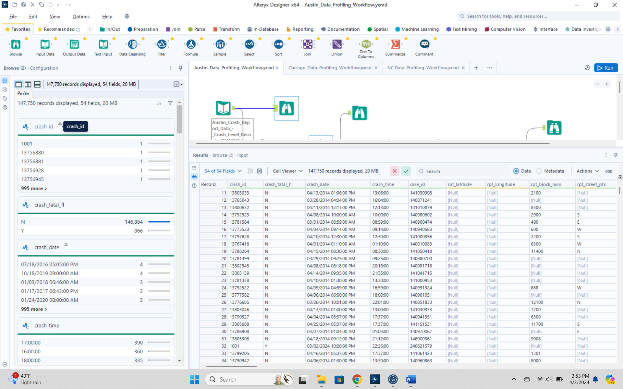

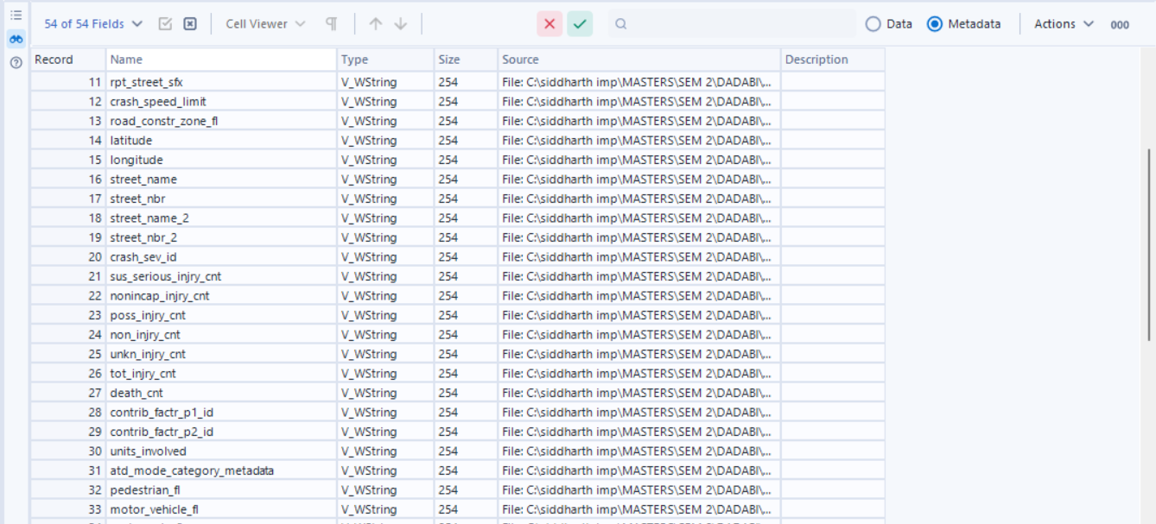

**Issue with the dataset :**  
1. All attributes are in “String” datatype

In order to fix this, we are using the **“Auto-field” tool** (this tool automatically detects and assigns data types to fields in a dataset, streamlining the data preparation process)**,** which yields us the following result.

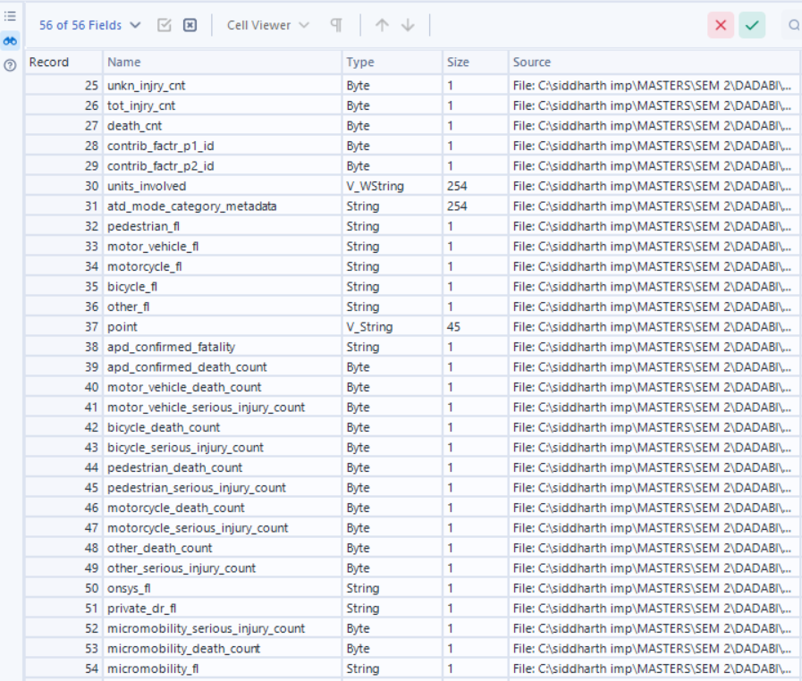

2. “Crash_date” column contains both the date and the time delimited by a space bar in the format (MM/dd/yyyy HH:MM:SS AM/PM).   
  
Later we implement the **“Text to Columns” tool** (this column splits a single field into multiple columns based on a delimiter or fixed width, aiding in data restructuring and normalization)

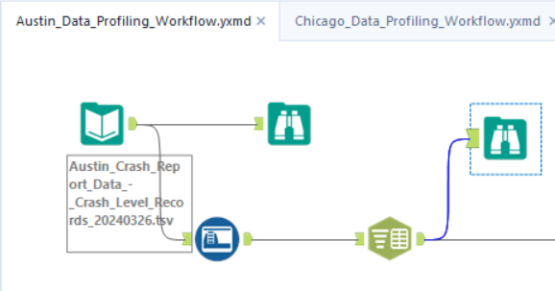

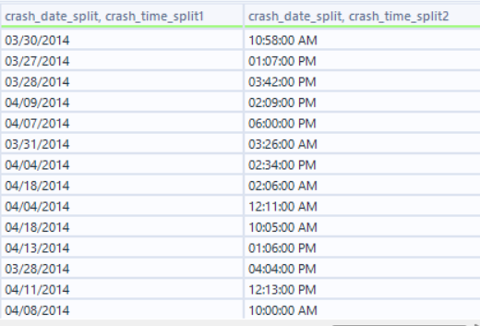

3. Now, we need to **convert the Crash date column to “Date” datatype from String** for which I will use the **“Date-Time Parse” tool. (this** tool is used to convert string data representing dates and times into the proper DateTime format, allowing for consistent and accurate handling of date and time data in workflows.**)**

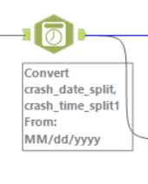

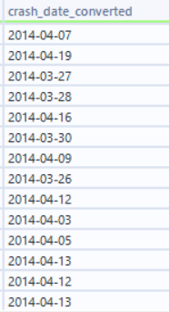

4. Now we can convert the datatypes and lengths of a few columns according to our interpretation from the profile tab. All this can be done using the **“select tool”,** fixing the datatypes and later select only the columns required. (wherein we won`t select :

* the previous “crash date” column, which was in String format
* both “newly added split columns” as we have the converted crash date column and an already existing time column
* “point” column as we have latitude and longitude data in already existing distinct columns)

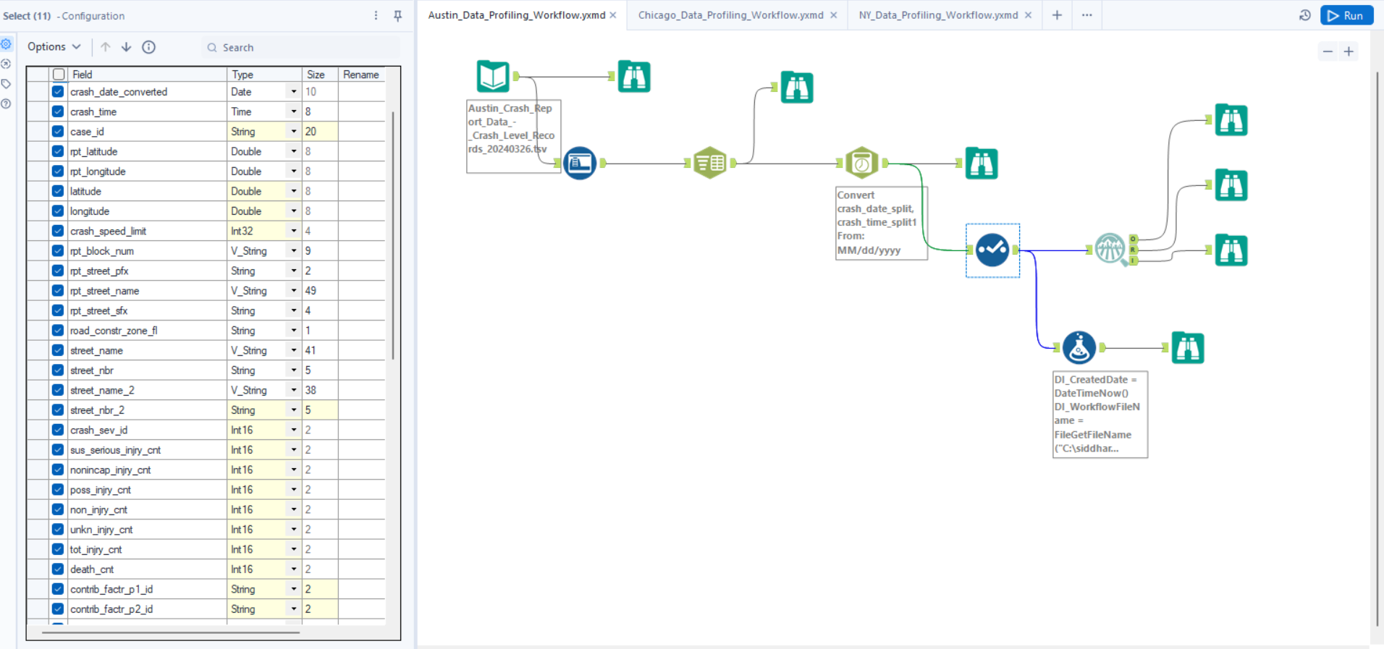

5. After using the select tool, in order to see an accumulated report of the null values, min-max length/value, inconsistencies in the data, we used the **“Field-Summary Tool” which helped us generate the following conclusions.**

|  |  |  |  |  |  |  |
| --- | --- | --- | --- | --- | --- | --- |
| **Name** | **% Missing** | **Unique Values** | **Latest Date** | **Earliest Date** | **Interval** | **Remarks** |
| crash_date_converted | 0.0% | 3,639 | 03/11/2024 00:00 | 03/26/2014 00:00 | Unknown |  |
| crash_time | 0.0% | 1,440 | 01/01/1400 23:00 | 01/01/1400 00:00 | Unknown |  |

|  |  |  |  |  |  |  |  |
| --- | --- | --- | --- | --- | --- | --- | --- |
| **Name** | **% Missing** | **Unique Values** | **Shortest Value** | **Longest Value** | **Min Value Count** | **Max Value Count** | **Remarks** |
| pedestrian_fl | 97.6% | 2 | Y | Y | 3,505 | 144,245 | This field has over 10% missing values. Consider imputing these values. Some values of this field have a small number of value counts. If Appropriate, consider combining some value levels together. |
| bicycle_fl | 98.3% | 2 | Y | Y | 2,444 | 145,306 | This field has over 10% missing values. Consider imputing these values. Some values of this field have a small number of value counts. If Appropriate, consider combining some value levels together. |
| motorcycle_fl | 97.6% | 2 | Y | Y | 3,602 | 144,148 | This field has over 10% missing values. Consider imputing these values. Some values of this field have a small number of value counts. If Appropriate, consider combining some value levels together. |
| crash_fatal_fl | 0.0% | 2 | N | N | 866 | 146,884 | Some values of this field have a small number of value counts. If Appropriate, consider combining some value levels together. |
| contrib_factr_p2_id | 96.9% | 66 | 3 | 67 | 1 | 143,235 | This field has over 10% missing values. Consider imputing these values. Some values of this field have a small number of value counts. If Appropriate, consider combining some value levels together. |
| motor_vehicle_fl | 0.8% | 2 | Y | Y | 1,116 | 146,634 | Some values of this field have a small number of value counts. If Appropriate, consider combining some value levels together. |
| case_id | 1.3% | 145,679 | . | 10000 BLK US HIGHWAY | 1 | 1,858 | Some values of this field have a small number of value counts. If Appropriate, consider combining some value levels together. |
| micromobility_fl | 99.8% | 2 | Y | Y | 311 | 147,439 | This field has over 10% missing values. Consider imputing these values. Some values of this field have a small number of value counts. If Appropriate, consider combining some value levels together. |
| road_constr_zone_fl | 0.0% | 3 | N | N | 2 | 139,901 | Some values of this field have a small number of value counts. If Appropriate, consider combining some value levels together. |
| contrib_factr_p1_id | 80.6% | 71 | 3 | 74 | 1 | 119,143 | This field has over 10% missing values. Consider imputing these values. Some values of this field have a small number of value counts. If Appropriate, consider combining some value levels together. |
| other_fl | 96.7% | 2 | Y | Y | 4,845 | 142,905 | This field has over 10% missing values. Consider imputing these values. Some values of this field have a small number of value counts. If Appropriate, consider combining some value levels together. |
| units_involved | 0.0% | 1,113 | Motorcycle | Other/Unknown & Passenger car & Passenger car & Large passenger vehicle & Large passenger vehicle & Large passenger vehicle & Large passenger vehicle & Passenger car & Motor vehicle – other & Large passenger vehicle & Passenger car & Other/Unknown & Pass | 1 | 34,141 | Some values of this field have a small number of value counts. If Appropriate, consider combining some value levels together. |
| street_name_2 | 0.0% | 3,398 | N/A | E ANDERSON EB TO N 35 SB RAMPN IH35 SB | 1 | 81,472 | Some values of this field have a small number of value counts. If Appropriate, consider combining some value levels together. |
| street_name | 0.0% | 4,631 | 441 | PRIVATE DRIVE TO THE CATHERINE APARTMENTS | 1 | 24,841 | Some values of this field have a small number of value counts. If Appropriate, consider combining some value levels together. |
| rpt_street_pfx | 45.9% | 9 | W | SW | 30 | 67,805 | This field has over 10% missing values. Consider imputing these values. Some values of this field have a small number of value counts. If Appropriate, consider combining some value levels together. |
| street_nbr_2 | 100.0% | 1 |  |  | 147,750 | 147,750 | This field has over 10% missing values. Consider imputing these values. |
| street_nbr | 58.9% | 9,828 | 0 | 11099 | 1 | 86,964 | This field has over 10% missing values. Consider imputing these values. Some values of this field have a small number of value counts. If Appropriate, consider combining some value levels together. |
| rpt_street_name | 0.0% | 9,796 | 1 | ED BLUESTEIN BLVD SB TO ED BLUESTEIN BLVD SVRD SB | 1 | 10,178 | Some values of this field have a small number of value counts. If Appropriate, consider combining some value levels together. |
| rpt_block_num | 13.3% | 4,789 | E | 11100 BLK | 1 | 19,611 | This field has over 10% missing values. Consider imputing these values. Some values of this field have a small number of value counts. If Appropriate, consider combining some value levels together. |
| apd_confirmed_fatality | 0.0% | 2 | N | N | 842 | 146,908 | Some values of this field have a small number of value counts. If Appropriate, consider combining some value levels together. |
| rpt_street_sfx | 34.1% | 19 | RD | BLVD | 40 | 50,340 | This field has over 10% missing values. Consider imputing these values. Some values of this field have a small number of value counts. If Appropriate, consider combining some value levels together. |
| atd_mode_category_metadata | 0.0% | 147,744 | [{"mode_id": 3, "mode_desc": "Motorcycle", "unit_id": 2262910, "death_cnt": 0, "sus_serious_injry_cnt": 0, "nonincap_injry_cnt": 0, "poss_injry_cnt": 0, "non_injry_cnt": 1, "unkn_injry_cnt": 0, "tot_injry_cnt": 0}] | [{"mode_id": 1, "mode_desc": "Passenger car", "unit_id": 2262335, "death_cnt": 0, "sus_serious_injry_cnt": 0, "nonincap_injry_cnt": 0, "poss_injry_cnt": 0, "non_injry_cnt": 1, "unkn_injry_cnt": 0, "tot_injry_cnt": 0}, {"mode_id": 1, "mode_desc": "Passeng | 1 | 7 | Some values of this field have a small number of value counts. If Appropriate, consider combining some value levels together. |
| private_dr_fl | 0.0% | 1 | N | N | 147,750 | 147,750 |  |
| onsys_fl | 0.0% | 2 | N | N | 73,041 | 74,709 |  |

|  |  |  |  |  |  |  |  |  |  |
| --- | --- | --- | --- | --- | --- | --- | --- | --- | --- |
| **Name** | **Plot** | **% Missing** | **Unique Values** | **Min** | **Mean** | **Median** | **Max** | **Std Dev** | **Remarks** |
| apd_confirmed_death_count | |  | | --- | |  | | 0.0% | 5 | 0.000 | 0.006 | 0.000 | 4.000 | 0.082 | This field has a small number of unique values, and appears to be a categorical field. Consider changing the field data type to "string". |
| micromobility_death_count | |  | | --- | |  | | 0.0% | 2 | 0.000 | 0.000 | 0.000 | 1.000 | 0.006 | This field has a small number of unique values, and appears to be a categorical field. Consider changing the field data type to "string". |
| rpt_latitude | |  | | --- | |  | | 93.0% | 7,977 | 25.837 | 30.297 | 30.295 | 36.500 | 0.377 | This field has over 10% missing values. Consider imputing these values. |
| sus_serious_injry_cnt | |  | | --- | |  | | 0.0% | 7 | 0.000 | 0.034 | 0.000 | 10.000 | 0.207 | This field has a small number of unique values, and appears to be a categorical field. Consider changing the field data type to "string". |
| motor_vehicle_serious_injury_count | |  | | --- | |  | | 0.0% | 6 | 0.000 | 0.023 | 0.000 | 5.000 | 0.176 | This field has a small number of unique values, and appears to be a categorical field. Consider changing the field data type to "string". |
| motorcycle_death_count | |  | | --- | |  | | 0.0% | 3 | 0.000 | 0.001 | 0.000 | 2.000 | 0.030 | This field has a small number of unique values, and appears to be a categorical field. Consider changing the field data type to "string". |
| motorcycle_serious_injury_count | |  | | --- | |  | | 0.0% | 3 | 0.000 | 0.005 | 0.000 | 2.000 | 0.071 | This field has a small number of unique values, and appears to be a categorical field. Consider changing the field data type to "string". |
| other_death_count | |  | | --- | |  | | 0.0% | 1 | 0.000 | 0.000 | 0.000 | 0.000 | 0.000 | This field has a small number of unique values, and appears to be a categorical field. Consider changing the field data type to "string". |
| pedestrian_death_count | |  | | --- | |  | | 0.0% | 3 | 0.000 | 0.002 | 0.000 | 2.000 | 0.047 | This field has a small number of unique values, and appears to be a categorical field. Consider changing the field data type to "string". |
| rpt_longitude | |  | | --- | |  | | 93.0% | 7,265 | -106.646 | -97.747 | -97.731 | -93.508 | 0.537 | This field has over 10% missing values. Consider imputing these values. |
| pedestrian_serious_injury_count | |  | | --- | |  | | 0.0% | 5 | 0.000 | 0.004 | 0.000 | 9.000 | 0.071 | This field has a small number of unique values, and appears to be a categorical field. Consider changing the field data type to "string". |
| bicycle_serious_injury_count | |  | | --- | |  | | 0.0% | 4 | 0.000 | 0.002 | 0.000 | 3.000 | 0.043 | This field has a small number of unique values, and appears to be a categorical field. Consider changing the field data type to "string". |
| micromobility_serious_injury_count | |  | | --- | |  | | 0.0% | 3 | 0.000 | 0.000 | 0.000 | 2.000 | 0.018 | This field has a small number of unique values, and appears to be a categorical field. Consider changing the field data type to "string". |
| motor_vehicle_death_count | |  | | --- | |  | | 0.0% | 5 | 0.000 | 0.003 | 0.000 | 4.000 | 0.059 | This field has a small number of unique values, and appears to be a categorical field. Consider changing the field data type to "string". |
| bicycle_death_count | |  | | --- | |  | | 0.0% | 2 | 0.000 | 0.000 | 0.000 | 1.000 | 0.014 | This field has a small number of unique values, and appears to be a categorical field. Consider changing the field data type to "string". |
| other_serious_injury_count | |  | | --- | |  | | 0.0% | 3 | 0.000 | 0.000 | 0.000 | 3.000 | 0.009 | This field has a small number of unique values, and appears to be a categorical field. Consider changing the field data type to "string". |
| death_cnt | |  | | --- | |  | | 0.0% | 5 | 0.000 | 0.006 | 0.000 | 4.000 | 0.082 | This field has a small number of unique values, and appears to be a categorical field. Consider changing the field data type to "string". |
| crash_sev_id | |  | | --- | |  | | 0.0% | 8 | 0.000 | 3.707 | 5.000 | 99.000 | 1.754 | This field has a small number of unique values, and appears to be a categorical field. Consider changing the field data type to "string". |
| unkn_injry_cnt | |  | | --- | |  | | 0.0% | 17 | 0.000 | 0.116 | 0.000 | 41.000 | 0.418 |  |
| poss_injry_cnt | |  | | --- | |  | | 0.0% | 17 | 0.000 | 0.339 | 0.000 | 20.000 | 0.728 |  |
| latitude | |  | | --- | |  | | 1.5% | 96,362 | 30.099 | 30.299 | 30.285 | 30.512 | 0.083 |  |
| crash_speed_limit | |  | | --- | |  | | 0.0% | 29 | -1.000 | 34.758 | 40.000 | 85.000 | 23.233 |  |
| longitude | |  | | --- | |  | | 1.5% | 96,265 | -97.927 | -97.738 | -97.736 | -97.570 | 0.053 |  |
| crash_id | |  | | --- | |  | | 0.0% | 147,750 | 1,001.000 | 16,810,778.317 | 16,758,228.500 | 180,290,542.000 | 1,832,197.355 |  |
| tot_injry_cnt | |  | | --- | |  | | 0.0% | 19 | 0.000 | 0.642 | 0.000 | 21.000 | 0.935 |  |
| non_injry_cnt | |  | | --- | |  | | 0.0% | 47 | 0.000 | 1.850 | 2.000 | 56.000 | 1.637 |  |
| nonincap_injry_cnt | |  | | --- | |  | | 0.0% | 15 | 0.000 | 0.269 | 0.000 | 14.000 | 0.625 |  |

6. The null values in any column can be filled using imputation methods using the **“imputation tool”** and the “not-ok” values can be cleansed using the **“data-cleaning” tool** in Alteryx.

7. Further, we used the **“Formula Tool”** in order to add 2 more columns to the staged table.

(the Formula tool is used for creating new calculated fields, transforming data, and performing operations like mathematical calculations, string manipulations, and conditional statements within a workflow).

(**DI_CreatedDate, DI_WorkfileName**) : Process shown in the screenshot below.

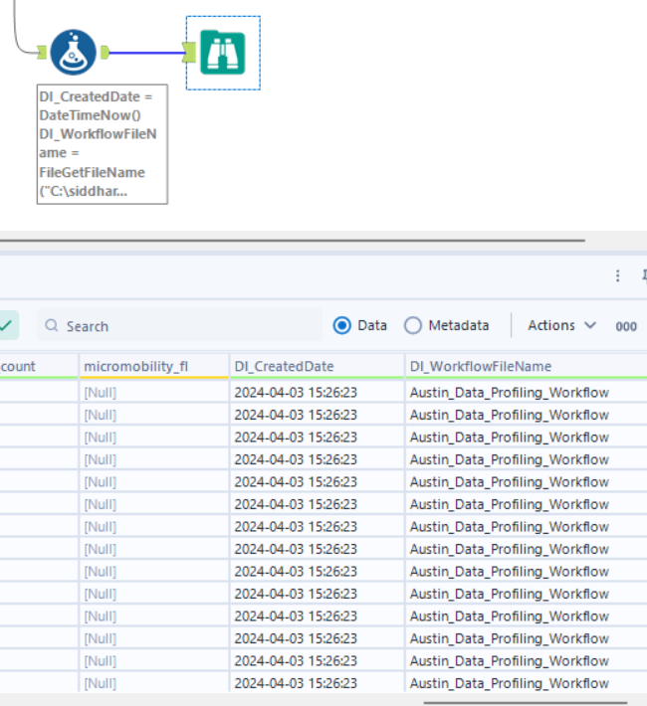

**Screenshot of whole Alteryx Workflow:**

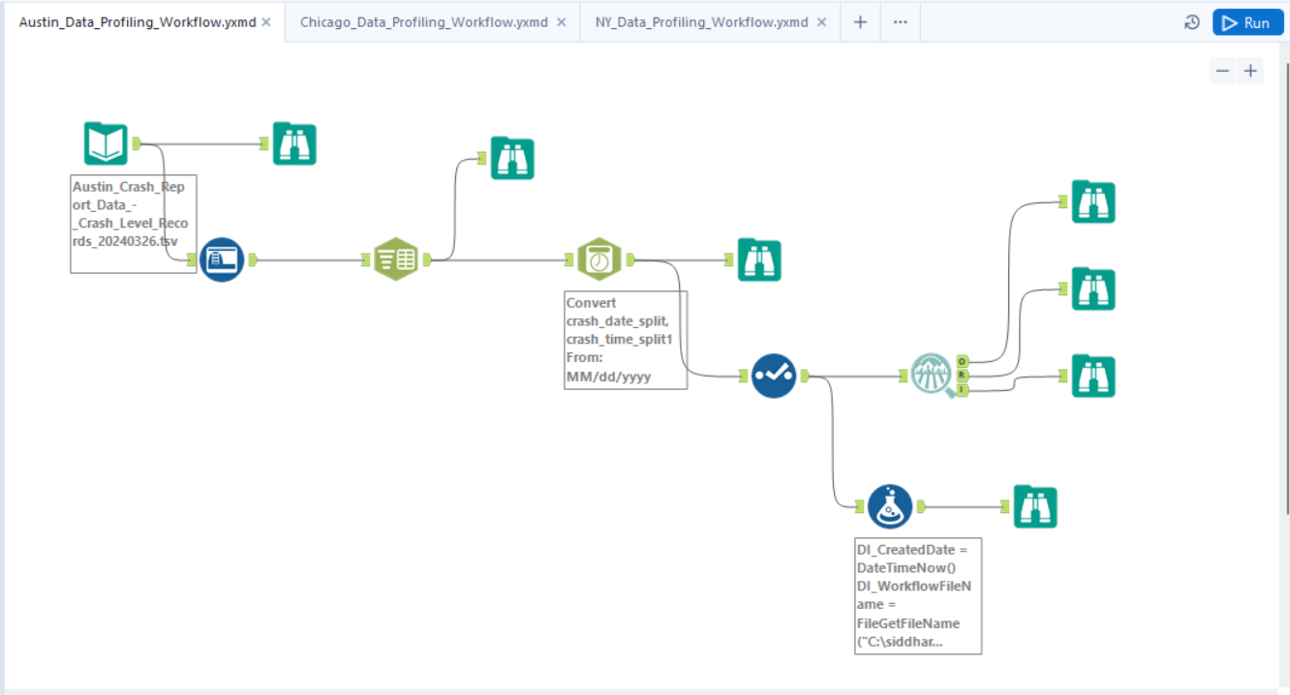

**Runtime:**

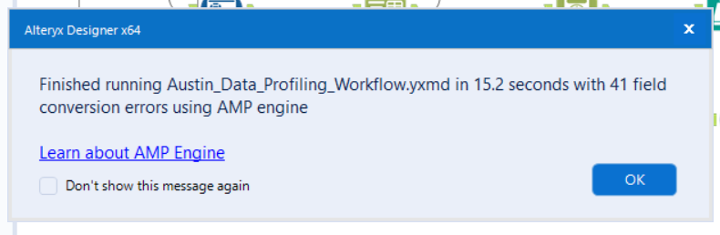

**Alteryx : Data Profiling Report (Part 2)**

**Dataset :** [**https://data.cityofchicago.org/Transportation/Traffic-Crashes-Crashes/85ca-t3if/about_data**](https://data.cityofchicago.org/Transportation/Traffic-Crashes-Crashes/85ca-t3if/about_data)

**Description :** Crash data shows information about each traffic crash on city streets within the City of Chicago limits and under the jurisdiction of Chicago Police Department (CPD).

**Number of attributes : 48,**

**Record Count : 817723,**

**Tool used for concluding the above info : “Browse Tool” (this** tool is used to view the data at any point in the workflow, providing a quick and easy way to inspect the results of data transformations and manipulations)

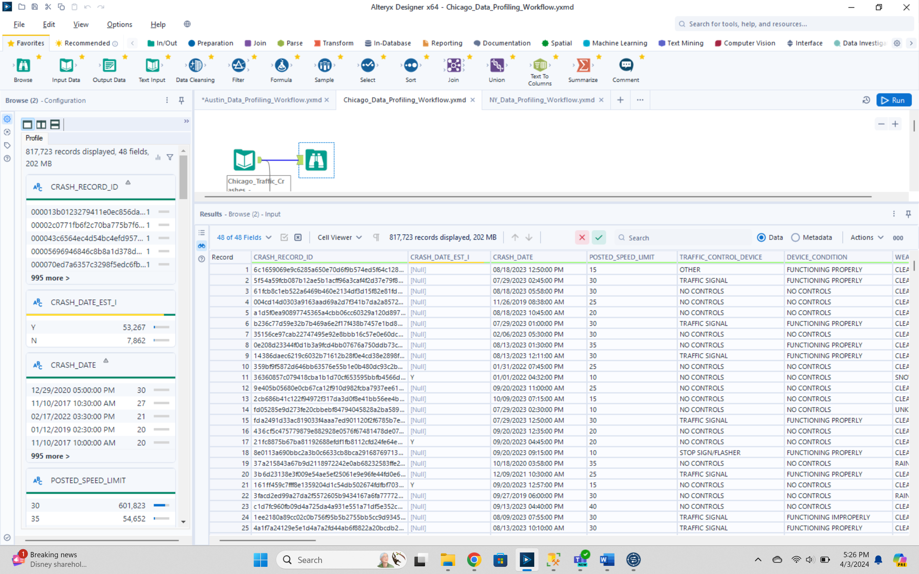

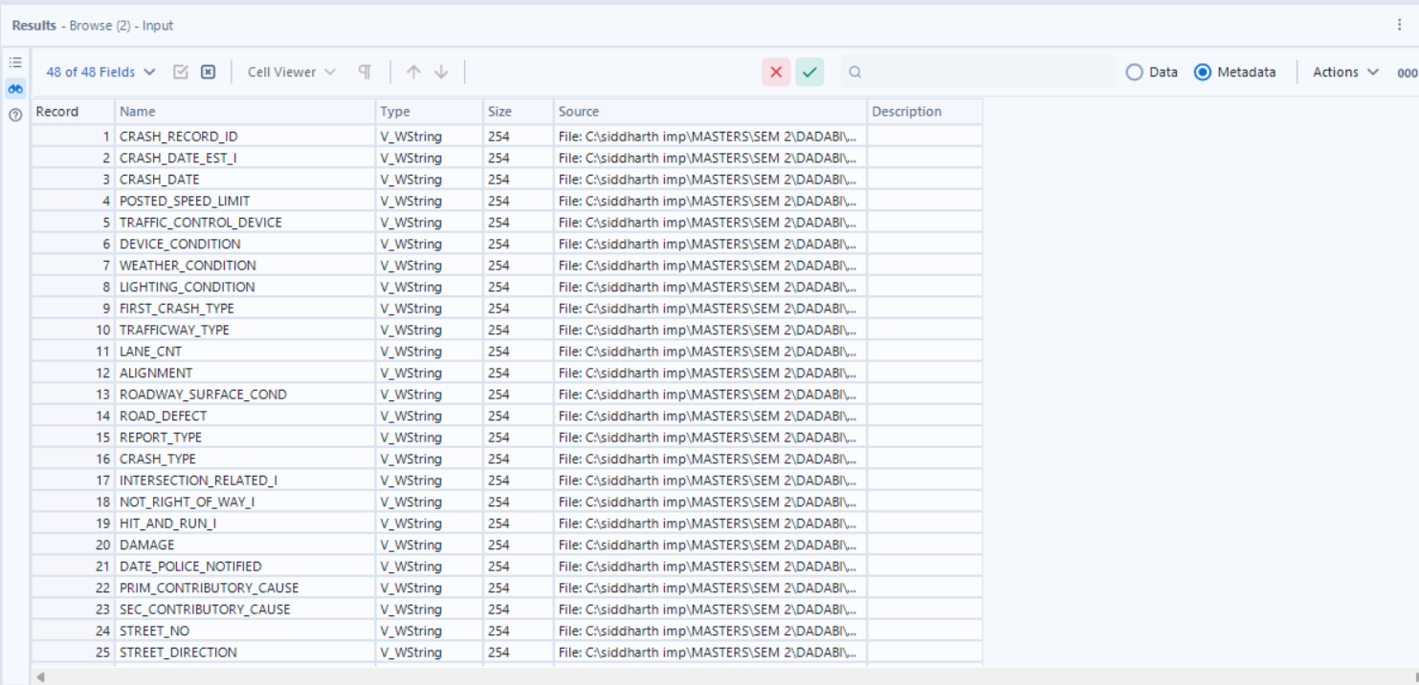

**Issue with the dataset :**  
1. All attributes are in “String” datatype

In order to fix this, we are using the **“Auto-field” tool** (this tool automatically detects and assigns data types to fields in a dataset, streamlining the data preparation process)**,** which yields us the following result.

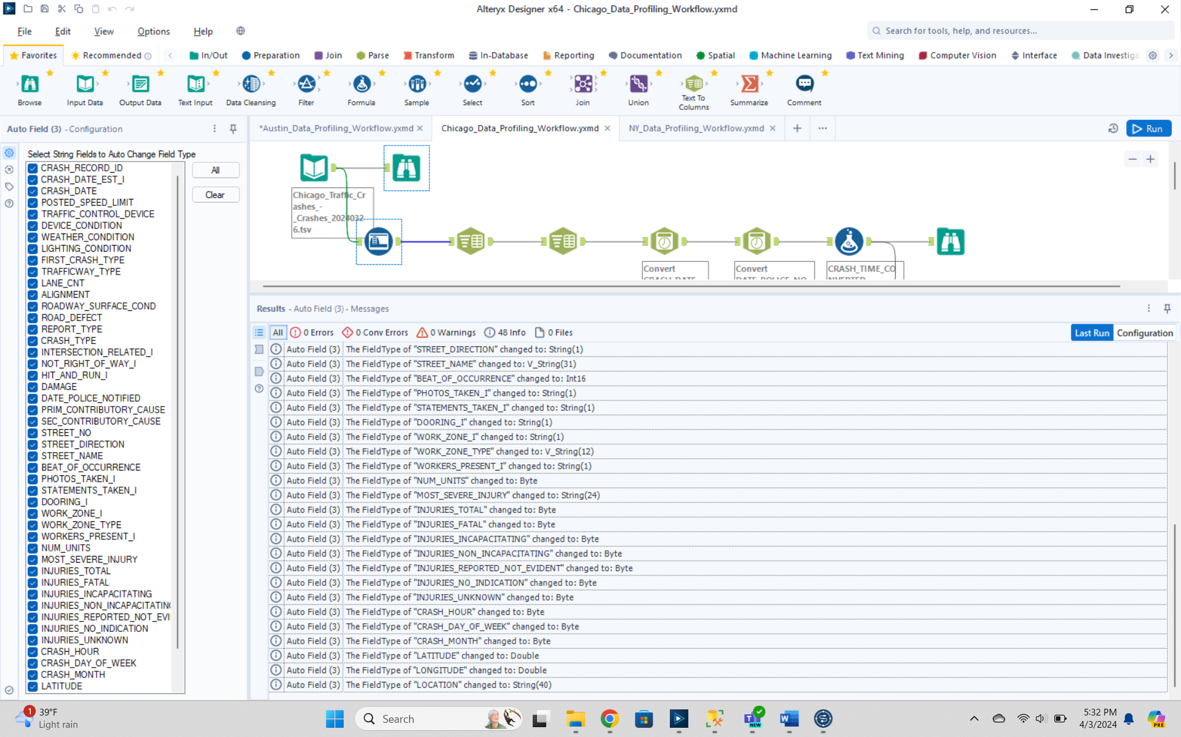

2. “Crash_date” & “Date_policie_notified” column contains both the date and the time delimited by a space bar in the format (MM/dd/yyyy HH:MM:SS AM/PM).   
  
Later we implement the **“Text to Columns” tool** (this column splits a single field into multiple columns based on a delimiter or fixed width, aiding in data restructuring and normalization)

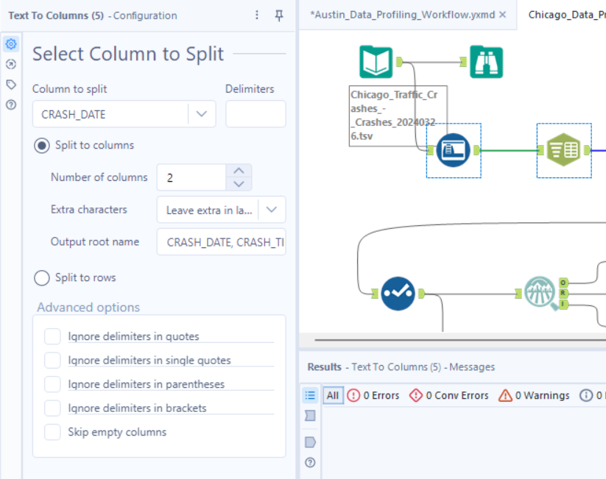

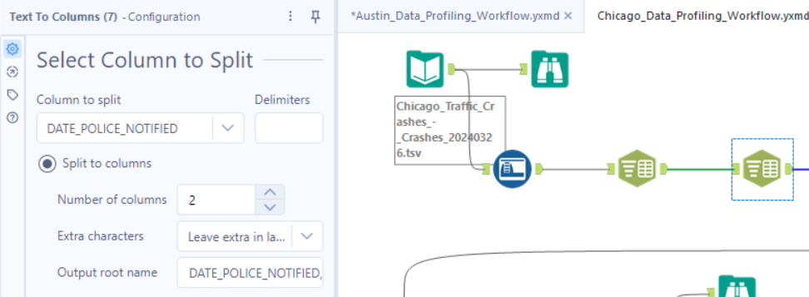

3. Now, we need to **convert the newly separated columns containing “Crash_date” and “Date Police Notified” to “Date” datatype from String** for which I will use the **“Date-Time Parse” tool. (this** tool is used to convert string data representing dates and times into the proper DateTime format, allowing for consistent and accurate handling of date and time data in workflows.**)**

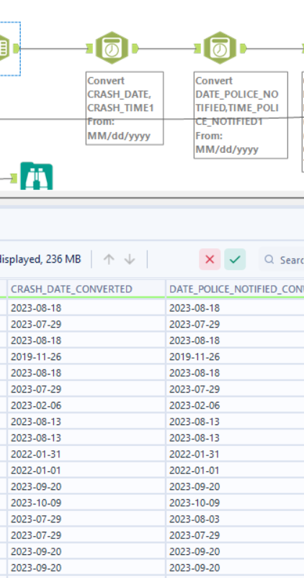

4. Further, we used the **“Formula Tool”** in order to add 2 more columns (DI_CreatedDate, DI_WorkflowFileName) to the staged table and convert both the split time columns (**one containing crash time and the other containing time_police_notified)** into 24 hour time format.

(the Formula tool is used for creating new calculated fields, transforming data, and performing operations like mathematical calculations, string manipulations, and conditional statements within a workflow).

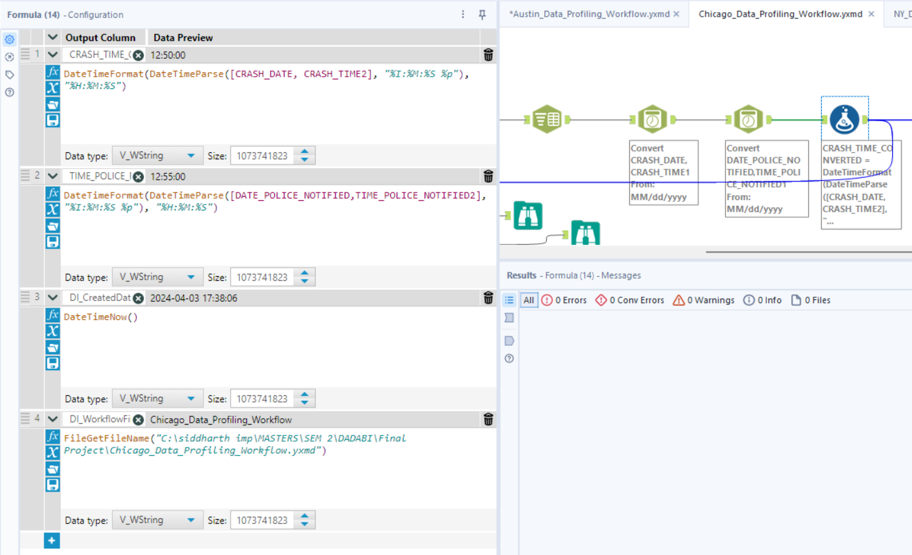

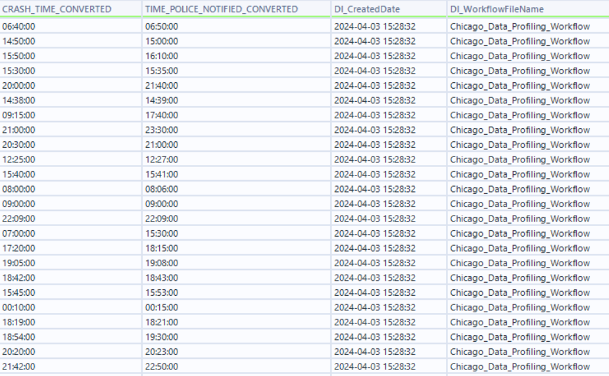

5. Now we can convert the datatypes and lengths of a few columns according to our interpretation from the profile tab. All this can be done using the **“select tool”,** fixing the datatypes and later select only the columns required. (wherein we won`t select :

* the previous “crash date” and “date_police_notified” column, which was in String format
* “newly added split columns” as we have the converted crash date column, converted_date_police_notified and the respective time columns as well.
* “location” column as we have latitude and longitude data in already existing distinct columns)

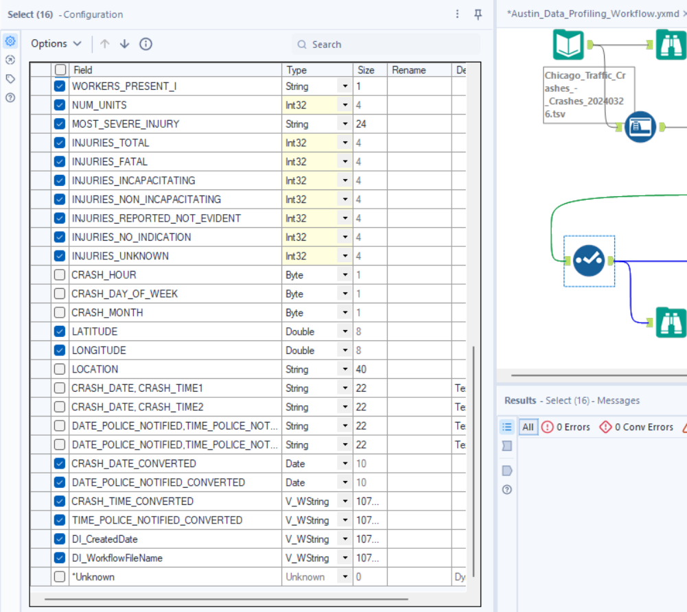

6. After using the select tool, in order to see an accumulated report of the null values, min-max length/value, inconsistencies in the data, we used the **“Field-Summary Tool” which helped us generate the following conclusions.**

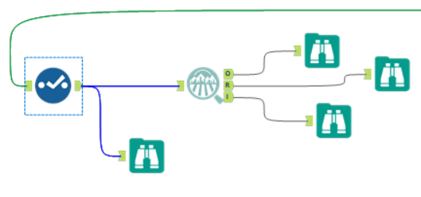

|  |  |  |  |  |  |  |
| --- | --- | --- | --- | --- | --- | --- |
| **Name** | **% Missing** | **Unique Values** | **Latest Date** | **Earliest Date** | **Interval** | **Remarks** |
| DATE_POLICE_NOTIFIED_CONVERTED | 0.0% | 3,161 | 03/26/2024 00:00 | 06/01/2013 00:00 | Unknown |  |
| CRASH_DATE_CONVERTED | 0.0% | 3,193 | 03/26/2024 00:00 | 03/03/2013 00:00 | Unknown |  |

|  |  |  |  |  |  |  |  |
| --- | --- | --- | --- | --- | --- | --- | --- |
| **Name** | **% Missing** | **Unique Values** | **Shortest Value** | **Longest Value** | **Min Value Count** | **Max Value Count** | **Remarks** |
| WEATHER_CONDITION | 0.0% | 12 | SNOW | BLOWING SAND, SOIL, DIRT | 7 | 641,373 | Some values of this field have a small number of value counts. If Appropriate, consider combining some value levels together. |
| CRASH_DATE_EST_I | 92.5% | 3 | Y | Y | 7,862 | 756,594 | This field has over 10% missing values. Consider imputing these values. Some values of this field have a small number of value counts. If Appropriate, consider combining some value levels together. |
| LIGHTING_CONDITION | 0.0% | 6 | DUSK | DARKNESS, LIGHTED ROAD | 13,689 | 522,973 | Some values of this field have a small number of value counts. If Appropriate, consider combining some value levels together. |
| DOORING_I | 99.7% | 3 | Y | Y | 824 | 815,211 | This field has over 10% missing values. Consider imputing these values. Some values of this field have a small number of value counts. If Appropriate, consider combining some value levels together. |
| ROAD_DEFECT | 0.0% | 7 | OTHER | DEBRIS ON ROADWAY | 616 | 657,425 | Some values of this field have a small number of value counts. If Appropriate, consider combining some value levels together. |
| CRASH_TIME_CONVERTED | 0.0% | 1,440 | 12:50:00 | 12:50:00 | 32 | 11,658 | Some values of this field have a small number of value counts. If Appropriate, consider combining some value levels together. |
| STREET_NAME | 0.0% | 1,642 | 82ND | MICHIGAN AVE 175 E CHESTNUT AVE | 1 | 22,319 | Some values of this field have a small number of value counts. If Appropriate, consider combining some value levels together. |
| CRASH_RECORD_ID | 0.0% | 817,723 | 6c1659069e9c6285a650e70d6f9b574ed5f64c12888479093dfeef179c0344ec6d2057eae224b5c0d5dfc278c0a237f8c22543f07fdef2e4a95a3849871c9345 | 6c1659069e9c6285a650e70d6f9b574ed5f64c12888479093dfeef179c0344ec6d2057eae224b5c0d5dfc278c0a237f8c22543f07fdef2e4a95a3849871c9345 | 1 | 1 | Some values of this field have a small number of value counts. If Appropriate, consider combining some value levels together. |
| FIRST_CRASH_TYPE | 0.0% | 18 | ANGLE | SIDESWIPE OPPOSITE DIRECTION | 45 | 190,062 | Some values of this field have a small number of value counts. If Appropriate, consider combining some value levels together. |
| REPORT_TYPE | 3.0% | 4 | AMENDED | NOT ON SCENE (DESK REPORT) | 240 | 447,696 | Some values of this field have a small number of value counts. If Appropriate, consider combining some value levels together. |
| TRAFFICWAY_TYPE | 0.0% | 20 | RAMP | DIVIDED - W/MEDIAN (NOT RAISED) | 168 | 355,079 | Some values of this field have a small number of value counts. If Appropriate, consider combining some value levels together. |
| STATEMENTS_TAKEN_I | 97.8% | 3 | Y | Y | 3,384 | 799,465 | This field has over 10% missing values. Consider imputing these values. Some values of this field have a small number of value counts. If Appropriate, consider combining some value levels together. |
| STREET_DIRECTION | 0.0% | 5 | W | W | 4 | 292,260 | Some values of this field have a small number of value counts. If Appropriate, consider combining some value levels together. |
| ALIGNMENT | 0.0% | 6 | CURVE, LEVEL | STRAIGHT ON HILLCREST | 364 | 797,888 | Some values of this field have a small number of value counts. If Appropriate, consider combining some value levels together. |
| TRAFFIC_CONTROL_DEVICE | 0.0% | 19 | OTHER | PEDESTRIAN CROSSING SIGN | 25 | 464,816 | Some values of this field have a small number of value counts. If Appropriate, consider combining some value levels together. |
| HIT_AND_RUN_I | 68.7% | 3 | Y | Y | 10,994 | 561,774 | This field has over 10% missing values. Consider imputing these values. Some values of this field have a small number of value counts. If Appropriate, consider combining some value levels together. |
| WORK_ZONE_I | 99.4% | 3 | Y | Y | 1,052 | 813,053 | This field has over 10% missing values. Consider imputing these values. Some values of this field have a small number of value counts. If Appropriate, consider combining some value levels together. |
| TIME_POLICE_NOTIFIED_CONVERTED | 0.0% | 1,440 | 12:55:00 | 12:55:00 | 54 | 8,405 | Some values of this field have a small number of value counts. If Appropriate, consider combining some value levels together. |
| PHOTOS_TAKEN_I | 98.7% | 3 | Y | Y | 2,665 | 806,948 | This field has over 10% missing values. Consider imputing these values. Some values of this field have a small number of value counts. If Appropriate, consider combining some value levels together. |
| DEVICE_CONDITION | 0.0% | 8 | OTHER | WORN REFLECTIVE MATERIAL | 95 | 470,240 | Some values of this field have a small number of value counts. If Appropriate, consider combining some value levels together. |
| MOST_SEVERE_INJURY | 0.2% | 6 | FATAL | NONINCAPACITATING INJURY | 899 | 703,419 | Some values of this field have a small number of value counts. If Appropriate, consider combining some value levels together. |
| NOT_RIGHT_OF_WAY_I | 95.4% | 3 | Y | Y | 3,452 | 780,015 | This field has over 10% missing values. Consider imputing these values. Some values of this field have a small number of value counts. If Appropriate, consider combining some value levels together. |
| SEC_CONTRIBUTORY_CAUSE | 0.0% | 40 | ANIMAL | OPERATING VEHICLE IN ERRATIC, RECKLESS, CARELESS, NEGLIGENT OR AGGRESSIVE MANNER | 56 | 335,814 | Some values of this field have a small number of value counts. If Appropriate, consider combining some value levels together. |
| DI_CreatedDate | 0.0% | 11 | 2024-04-03 15:28:32 | 2024-04-03 15:28:32 | 7,448 | 150,036 | Some values of this field have a small number of value counts. If Appropriate, consider combining some value levels together. |
| PRIM_CONTRIBUTORY_CAUSE | 0.0% | 40 | ANIMAL | OPERATING VEHICLE IN ERRATIC, RECKLESS, CARELESS, NEGLIGENT OR AGGRESSIVE MANNER | 23 | 318,311 | Some values of this field have a small number of value counts. If Appropriate, consider combining some value levels together. |
| INTERSECTION_RELATED_I | 77.1% | 3 | Y | Y | 8,907 | 630,174 | This field has over 10% missing values. Consider imputing these values. Some values of this field have a small number of value counts. If Appropriate, consider combining some value levels together. |
| WORKERS_PRESENT_I | 99.9% | 3 | Y | Y | 138 | 816,529 | This field has over 10% missing values. Consider imputing these values. Some values of this field have a small number of value counts. If Appropriate, consider combining some value levels together. |
| WORK_ZONE_TYPE | 99.6% | 5 | UTILITY | CONSTRUCTION | 228 | 814,105 | This field has over 10% missing values. Consider imputing these values. Some values of this field have a small number of value counts. If Appropriate, consider combining some value levels together. |
| ROADWAY_SURFACE_COND | 0.0% | 7 | DRY | SAND, MUD, DIRT | 303 | 603,295 | Some values of this field have a small number of value counts. If Appropriate, consider combining some value levels together. |
| DAMAGE | 0.0% | 3 | OVER $1,500 | $501 - $1,500 | 93,373 | 507,718 |  |
| CRASH_TYPE | 0.0% | 2 | NO INJURY / DRIVE AWAY | INJURY AND / OR TOW DUE TO CRASH | 218,340 | 599,383 |  |
| DI_WorkflowFileName | 0.0% | 1 | Chicago_Data_Profiling_Workflow | Chicago_Data_Profiling_Workflow | 817,723 | 817,723 |  |

|  |
| --- |
|  |
| **Name** | **Plot** | **% Missing** | **Unique Values** | **Min** | **Mean** | **Median** | **Max** | **Std Dev** | **Remarks** |
| LANE_CNT | |  | | --- | |  | | 75.7% | 42 | 0.000 | 13.330 | 2.000 | 1,191,625.000 | 2,961.601 | This field has over 10% missing values. Consider imputing these values. |
| INJURIES_FATAL | |  | | --- | |  | | 0.2% | 6 | 0.000 | 0.001 | 0.000 | 4.000 | 0.037 | This field has a small number of unique values, and appears to be a categorical field. Consider changing the field data type to "string". |
| INJURIES_UNKNOWN | |  | | --- | |  | | 0.2% | 2 | 0.000 | 0.000 | 0.000 | 0.000 | 0.000 | This field has a small number of unique values, and appears to be a categorical field. Consider changing the field data type to "string". |
| INJURIES_NO_INDICATION | |  | | --- | |  | | 0.2% | 49 | 0.000 | 2.003 | 2.000 | 61.000 | 1.157 |  |
| LONGITUDE | |  | | --- | |  | | 0.7% | 300,055 | -87.936 | -87.674 | -87.674 | 0.000 | 0.684 |  |
| NUM_UNITS | |  | | --- | |  | | 0.0% | 17 | 1.000 | 2.035 | 2.000 | 18.000 | 0.453 |  |
| STREET_NO | |  | | --- | |  | | 0.0% | 11,728 | 0.000 | 3,689.634 | 3,201.000 | 451,100.000 | 2,886.884 |  |
| LATITUDE | |  | | --- | |  | | 0.7% | 300,092 | 0.000 | 41.855 | 41.875 | 42.023 | 0.336 |  |
| BEAT_OF_OCCURRENCE | |  | | --- | |  | | 0.0% | 277 | 111.000 | 1,243.735 | 1,212.000 | 6,100.000 | 705.271 |  |
| INJURIES_REPORTED_NOT_EVIDENT | |  | | --- | |  | | 0.2% | 14 | 0.000 | 0.062 | 0.000 | 15.000 | 0.319 |  |
| INJURIES_NON_INCAPACITATING | |  | | --- | |  | | 0.2% | 20 | 0.000 | 0.107 | 0.000 | 21.000 | 0.422 |  |
| INJURIES_INCAPACITATING | |  | | --- | |  | | 0.2% | 11 | 0.000 | 0.020 | 0.000 | 10.000 | 0.165 |  |
| INJURIES_TOTAL | |  | | --- | |  | | 0.2% | 21 | 0.000 | 0.190 | 1.000 | 21.000 | 0.566 |  |
| POSTED_SPEED_LIMIT | |  | | --- | |  | | 0.0% | 46 | 0.000 | 28.406 | 30.000 | 99.000 | 6.166 |  |

7. The null values in any column can be filled using imputation methods using the **“imputation tool”** and the “not-ok” values can be cleansed using the **“data-cleaning” tool** in Alteryx.

**Screenshot of whole Alteryx Workflow:**

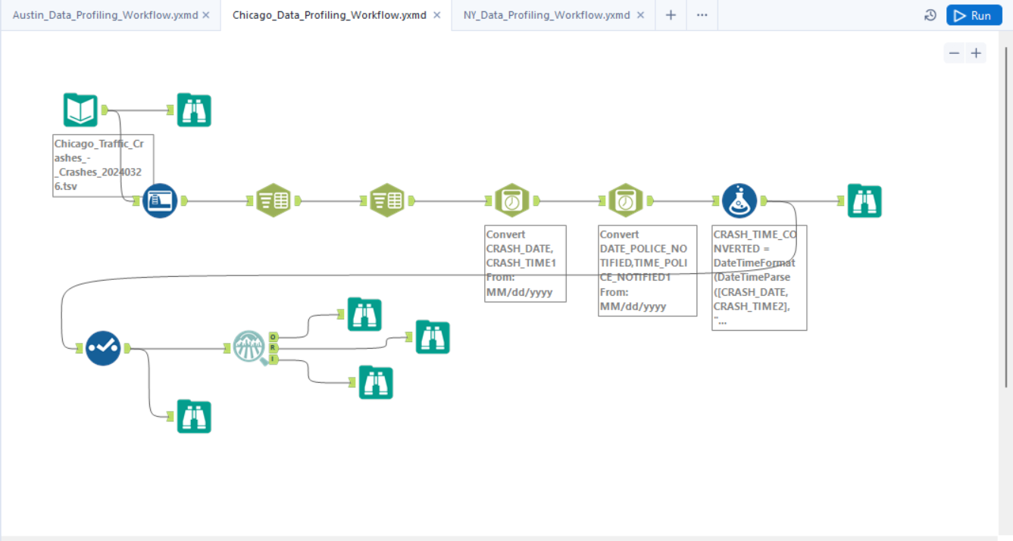

**Runtime:**

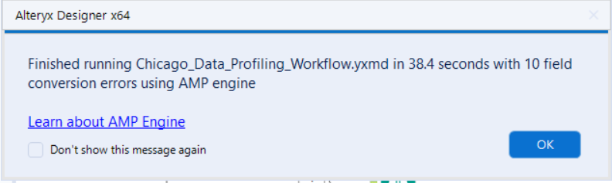

**Alteryx : Data Profiling Report (Part 3)**

**Dataset :** [**https://data.cityofnewyork.us/Public-Safety/Motor-Vehicle-Collisions-Crashes/h9gi-nx95/about_data**](https://data.cityofnewyork.us/Public-Safety/Motor-Vehicle-Collisions-Crashes/h9gi-nx95/about_data)

**Description :** The Motor Vehicle Collisions crash table contains details on the crash event. Each row represents a crash event. The Motor Vehicle Collisions data tables contain information from all police reported motor vehicle collisions in NYC

**Number of attributes : 29,**

**Record Count : 2075427,**

**Tool used for concluding the above info : “Browse Tool” (this** tool is used to view the data at any point in the workflow, providing a quick and easy way to inspect the results of data transformations and manipulations)

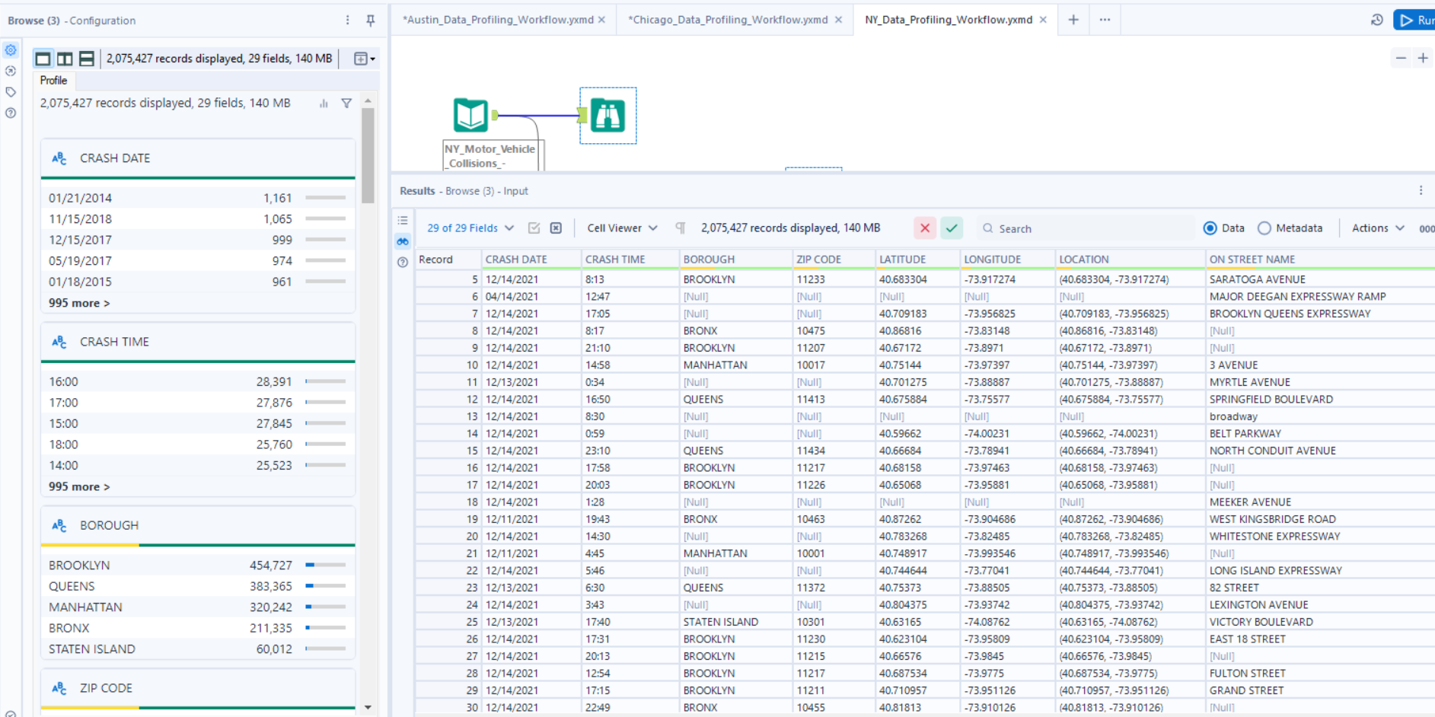

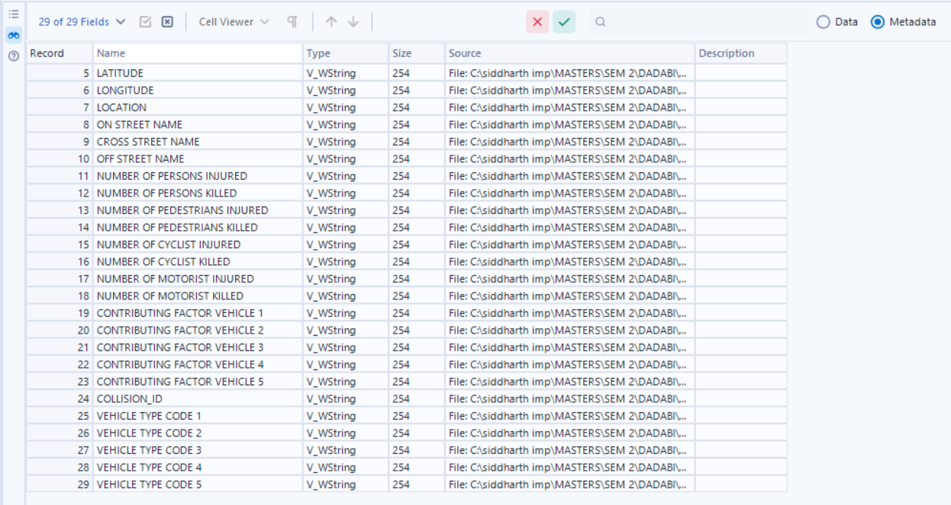

**Issue with the dataset :**  
1. All attributes are in “String” datatype

In order to fix this, we are using the **“Auto-field” tool** (this tool automatically detects and assigns data types to fields in a dataset, streamlining the data preparation process)**,** which yields us the following result.

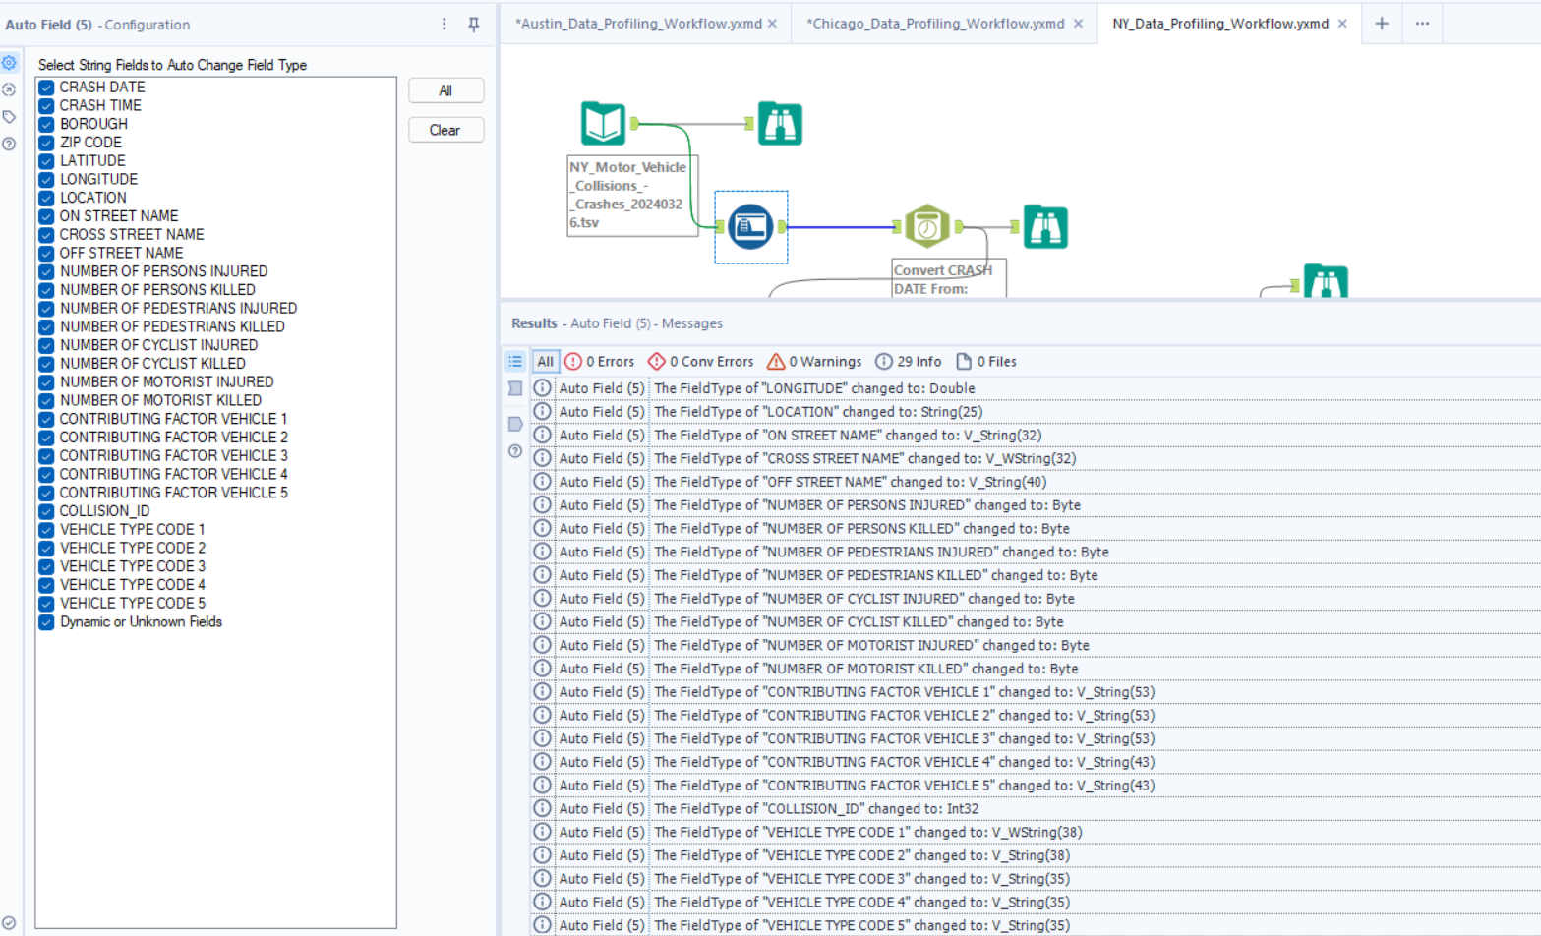

2. Now, we need to **convert the “Crash_date” column to “Date” datatype from String** for which I will use the **“Date-Time Parse” tool. (this** tool is used to convert string data representing dates and times into the proper DateTime format, allowing for consistent and accurate handling of date and time data in workflows.**)**

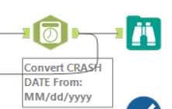

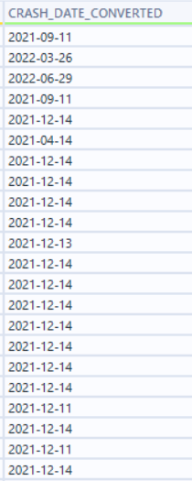

3. Further, we used the **“Formula Tool”** in order to add 2 more columns (DI_CreatedDate, DI_WorkflowFileName) to the staged table and clean “crash_time” column into unformed 24 hour time format.

(the Formula tool is used for creating new calculated fields, transforming data, and performing operations like mathematical calculations, string manipulations, and conditional statements within a workflow).

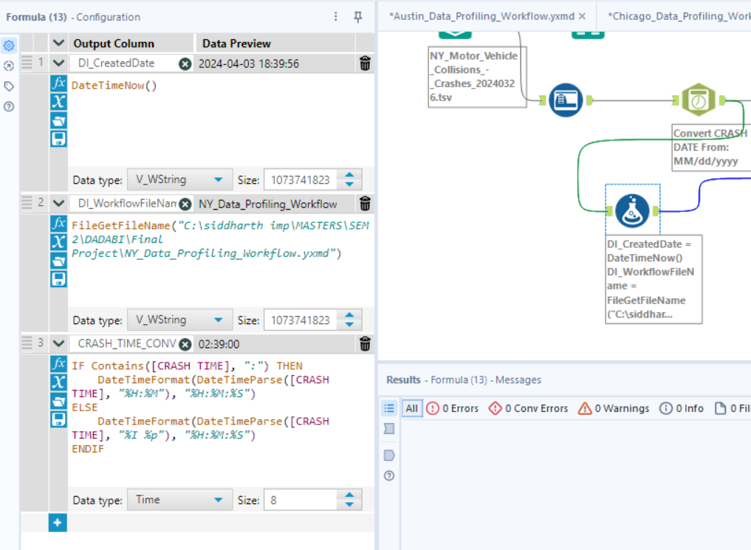

4. Now we can convert the datatypes and lengths of a few columns according to our interpretation from the profile tab. All this can be done using the **“select tool”,** fixing the datatypes and later select only the columns required. (wherein we won`t select :

* the previous “crash date” column, which was in String format
* “location” column as we have latitude and longitude data in already existing distinct columns)

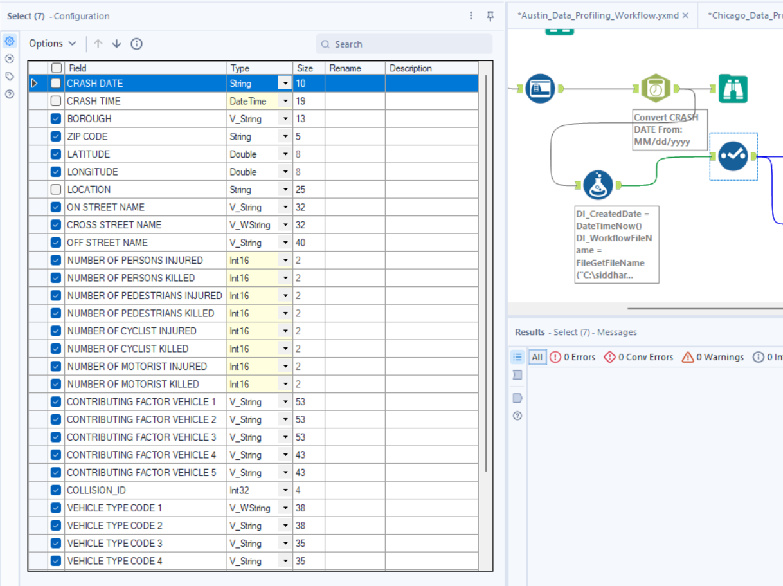

5. After using the select tool, in order to see an accumulated report of the null values, min-max length/value, inconsistencies in the data, we used the **“Field-Summary Tool” which helped us generate the following conclusions.**

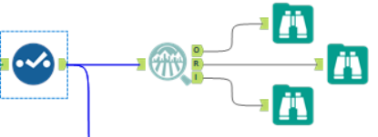

|  |  |  |  |  |  |  |  |  |  |
| --- | --- | --- | --- | --- | --- | --- | --- | --- | --- |
| **Name** | **Plot** | **% Missing** | **Unique Values** | **Min** | **Mean** | **Median** | **Max** | **Std Dev** | **Remarks** |
| LONGITUDE | |  | | --- | |  | | 11.3% | 98,352 | -201.360 | -73.752 | -73.926 | 0.000 | 3.723 | This field has over 10% missing values. Consider imputing these values. |
| NUMBER OF MOTORIST KILLED | |  | | --- | |  | | 0.0% | 6 | 0.000 | 0.001 | 0.000 | 5.000 | 0.027 | This field has a small number of unique values, and appears to be a categorical field. Consider changing the field data type to "string". |
| NUMBER OF PERSONS KILLED | |  | | --- | |  | | 0.0% | 8 | 0.000 | 0.001 | 0.000 | 8.000 | 0.041 | This field has a small number of unique values, and appears to be a categorical field. Consider changing the field data type to "string". |
| LATITUDE | |  | | --- | |  | | 11.3% | 126,595 | 0.000 | 40.628 | 40.722 | 43.344 | 1.981 | This field has over 10% missing values. Consider imputing these values. |
| NUMBER OF PEDESTRIANS KILLED | |  | | --- | |  | | 0.0% | 4 | 0.000 | 0.001 | 0.000 | 6.000 | 0.028 | This field has a small number of unique values, and appears to be a categorical field. Consider changing the field data type to "string". |
| NUMBER OF CYCLIST INJURED | |  | | --- | |  | | 0.0% | 5 | 0.000 | 0.027 | 0.000 | 4.000 | 0.163 | This field has a small number of unique values, and appears to be a categorical field. Consider changing the field data type to "string". |
| NUMBER OF CYCLIST KILLED | |  | | --- | |  | | 0.0% | 3 | 0.000 | 0.000 | 0.000 | 2.000 | 0.011 | This field has a small number of unique values, and appears to be a categorical field. Consider changing the field data type to "string". |
| NUMBER OF PERSONS INJURED | |  | | --- | |  | | 0.0% | 33 | 0.000 | 0.310 | 1.000 | 43.000 | 0.700 |  |
| NUMBER OF MOTORIST INJURED | |  | | --- | |  | | 0.0% | 31 | 0.000 | 0.223 | 0.000 | 43.000 | 0.661 |  |
| NUMBER OF PEDESTRIANS INJURED | |  | | --- | |  | | 0.0% | 14 | 0.000 | 0.057 | 0.000 | 27.000 | 0.244 |  |
| COLLISION_ID | |  | | --- | |  | | 0.0% | 2,075,427 | 22.000 | 3,159,626.962 | 3,673,954.000 | 4,712,252.000 | 1,505,149.883 |  |

|  |  |  |  |  |  |  |
| --- | --- | --- | --- | --- | --- | --- |
| **Name** | **% Missing** | **Unique Values** | **Latest Date** | **Earliest Date** | **Interval** | **Remarks** |
| CRASH_TIME_CONVERTED | 0.0% | 1,440 | 01/01/1400 23:00 | 01/01/1400 00:00 | Unknown |  |
| CRASH_DATE_CONVERTED | 0.0% | 4,283 | 03/22/2024 00:00 | 07/01/2012 00:00 | Unknown |  |

|  |  |  |  |  |  |  |  |
| --- | --- | --- | --- | --- | --- | --- | --- |
| **Name** | **% Missing** | **Unique Values** | **Shortest Value** | **Longest Value** | **Min Value Count** | **Max Value Count** | **Remarks** |
| VEHICLE TYPE CODE 1 | 0.7% | 1,635 | . | Enclosed Body - Nonremovable Enclosure | 1 | 576,659 | Some values of this field have a small number of value counts. If Appropriate, consider combining some value levels together. |
| ON STREET NAME | 21.2% | 13,081 |  | WILLIAMSBURG BRIDGE OUTER ROADWA | 1 | 440,569 | This field has over 10% missing values. Consider imputing these values. Some values of this field have a small number of value counts. If Appropriate, consider combining some value levels together. |
| CONTRIBUTING FACTOR VEHICLE 4 | 98.4% | 42 | Glare | Traffic Control Device Improper/Non-Working | 1 | 2,041,953 | This field has over 10% missing values. Consider imputing these values. Some values of this field have a small number of value counts. If Appropriate, consider combining some value levels together. |
| CONTRIBUTING FACTOR VEHICLE 5 | 99.6% | 31 | Glare | Traffic Control Device Improper/Non-Working | 1 | 2,066,358 | This field has over 10% missing values. Consider imputing these values. Some values of this field have a small number of value counts. If Appropriate, consider combining some value levels together. |
| CONTRIBUTING FACTOR VEHICLE 2 | 15.5% | 62 | 1 | Pedestrian/Bicyclist/Other Pedestrian Error/Confusion | 3 | 1,476,469 | This field has over 10% missing values. Consider imputing these values. Some values of this field have a small number of value counts. If Appropriate, consider combining some value levels together. |
| VEHICLE TYPE CODE 5 | 99.6% | 71 | C3 | Station Wagon/Sport Utility Vehicle | 1 | 2,066,635 | This field has over 10% missing values. Consider imputing these values. Some values of this field have a small number of value counts. If Appropriate, consider combining some value levels together. |
| OFF STREET NAME | 83.2% | 200,266 |  | 26-45 brooklyn queens expressway wes | 1 | 1,727,231 | This field has over 10% missing values. Consider imputing these values. Some values of this field have a small number of value counts. If Appropriate, consider combining some value levels together. |
| VEHICLE TYPE CODE 4 | 98.4% | 102 | PK | Station Wagon/Sport Utility Vehicle | 1 | 2,043,115 | This field has over 10% missing values. Consider imputing these values. Some values of this field have a small number of value counts. If Appropriate, consider combining some value levels together. |
| CROSS STREET NAME | 37.8% | 13,699 |  | CROSS BRONX EXPRESSWAY EXTENSION | 1 | 784,436 | This field has over 10% missing values. Consider imputing these values. Some values of this field have a small number of value counts. If Appropriate, consider combining some value levels together. |
| DI_CreatedDate | 0.0% | 14 | 2024-04-03 15:30:24 | 2024-04-03 15:30:24 | 3,481 | 435,682 | Some values of this field have a small number of value counts. If Appropriate, consider combining some value levels together. |
| CONTRIBUTING FACTOR VEHICLE 3 | 92.9% | 52 | 1 | Pedestrian/Bicyclist/Other Pedestrian Error/Confusion | 1 | 1,927,163 | This field has over 10% missing values. Consider imputing these values. Some values of this field have a small number of value counts. If Appropriate, consider combining some value levels together. |
| VEHICLE TYPE CODE 3 | 93.1% | 263 | PK | Station Wagon/Sport Utility Vehicle | 1 | 1,932,528 | This field has over 10% missing values. Consider imputing these values. Some values of this field have a small number of value counts. If Appropriate, consider combining some value levels together. |
| BOROUGH | 31.1% | 6 | BRONX | STATEN ISLAND | 60,012 | 645,746 | This field has over 10% missing values. Consider imputing these values. Some values of this field have a small number of value counts. If Appropriate, consider combining some value levels together. |
| CONTRIBUTING FACTOR VEHICLE 1 | 0.3% | 62 | 1 | Pedestrian/Bicyclist/Other Pedestrian Error/Confusion | 10 | 706,732 | Some values of this field have a small number of value counts. If Appropriate, consider combining some value levels together. |
| VEHICLE TYPE CODE 2 | 19.1% | 1,824 | 0 | Enclosed Body - Nonremovable Enclosure | 1 | 403,529 | This field has over 10% missing values. Consider imputing these values. Some values of this field have a small number of value counts. If Appropriate, consider combining some value levels together. |
| ZIP CODE | 31.1% | 236 |  | 11208 | 1 | 645,996 | This field has over 10% missing values. Consider imputing these values. Some values of this field have a small number of value counts. If Appropriate, consider combining some value levels together. |
| DI_WorkflowFileName | 0.0% | 1 | NY_Data_Profiling_Workflow | NY_Data_Profiling_Workflow | 2,075,427 | 2,075,427 |  |

6. The null values in any column can be filled using imputation methods using the **“imputation tool”** and the “not-ok” values can be cleansed using the **“data-cleaning” tool** in Alteryx.

**Screenshot of whole Alteryx Workflow:**

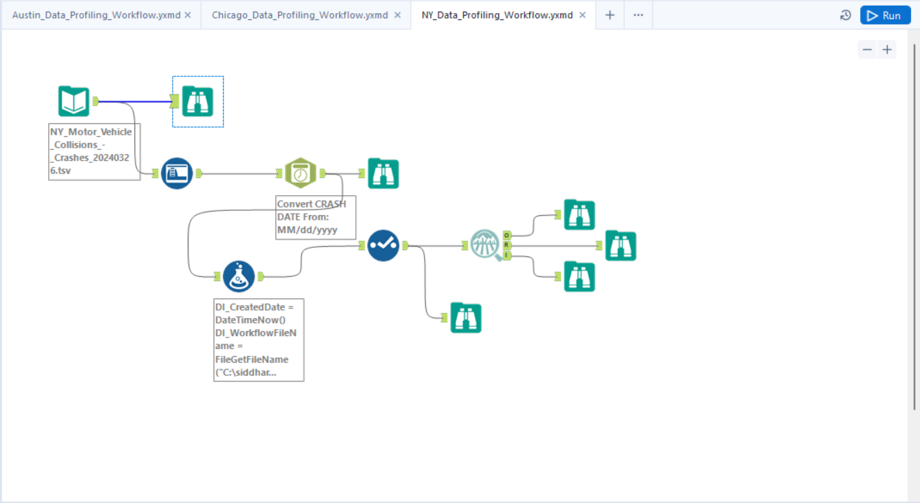

**Runtime:**

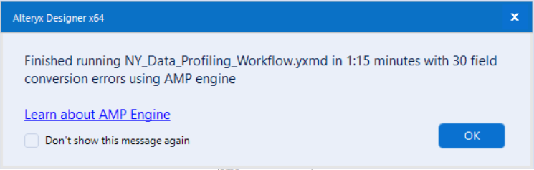

**YData Profiling Report (Part 1)**

We also performed YData-Profiling on all 3 datasets in order to explore how it works.

Austin Data:

<file:///C:/siddharth%20imp/MASTERS/SEM%202/DADABI/Final%20Project/Austin_Data_Profiling_Report.html>

Chicago Data:

<file:///C:/siddharth%20imp/MASTERS/SEM%202/DADABI/Final%20Project/Chicago_Data_Profiling_Report.html>

NY Data:

<file:///C:/siddharth%20imp/MASTERS/SEM%202/DADABI/Final%20Project/NYC_Motor_Vehicle_Collision.html>

**Talend Raw tables Staging Workflow & Preview + Row Count:**

1. Austin Data:

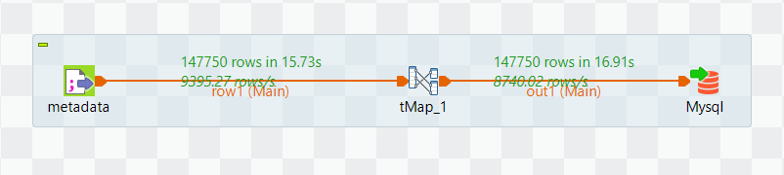

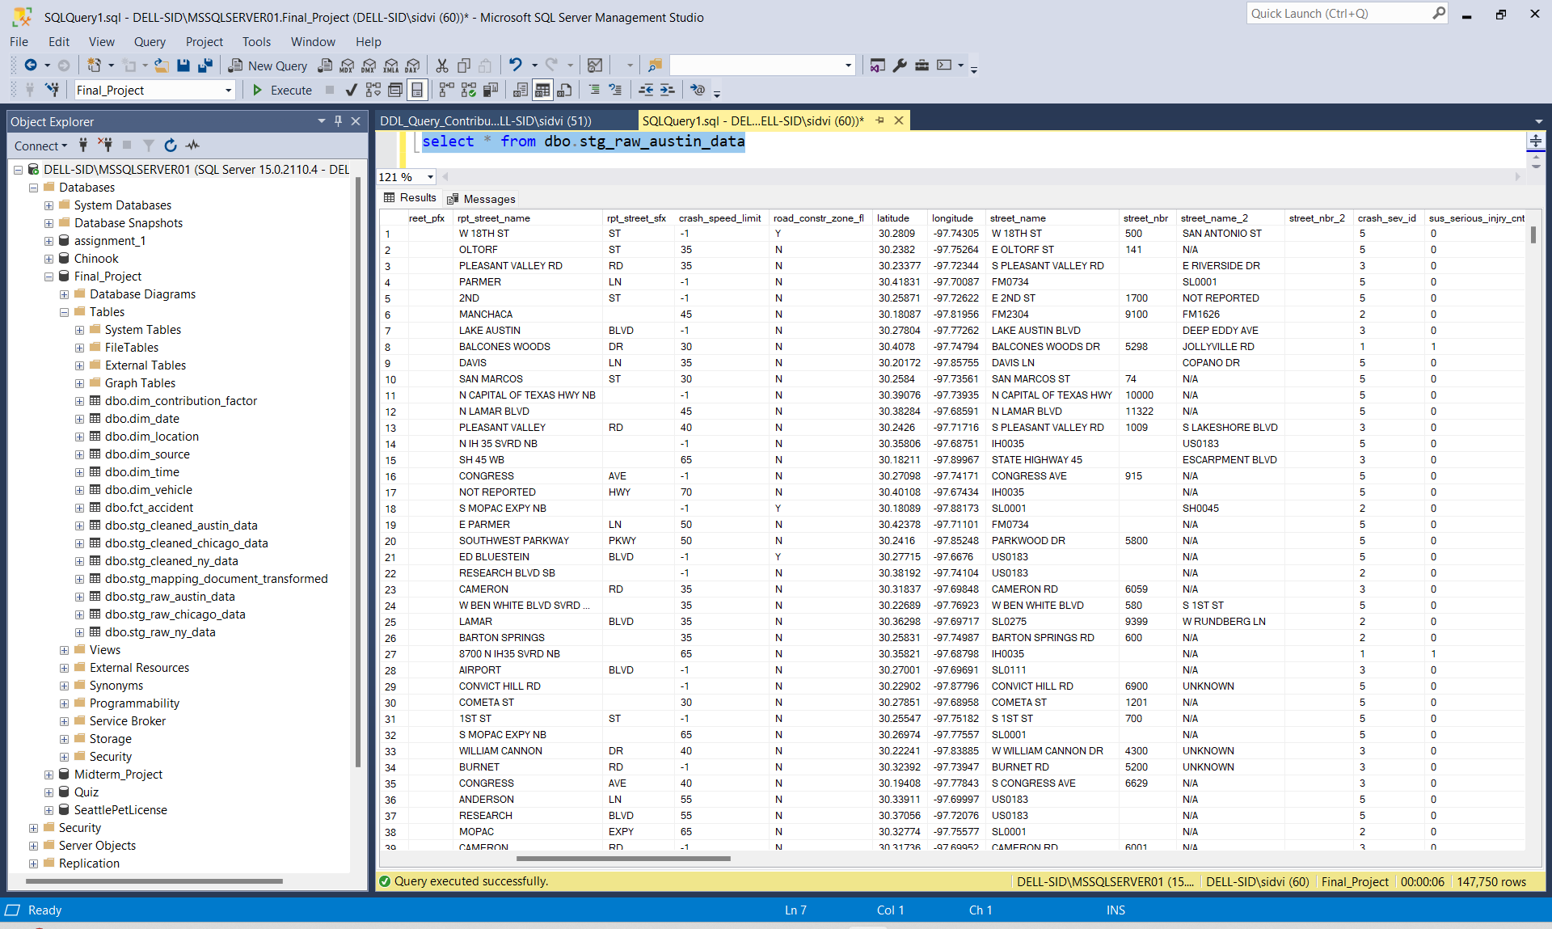

1. Chicago Data:

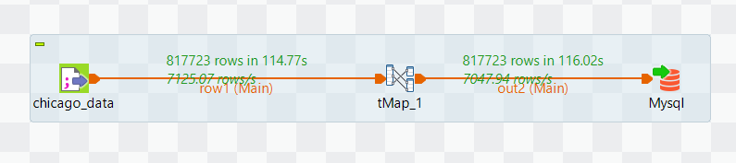

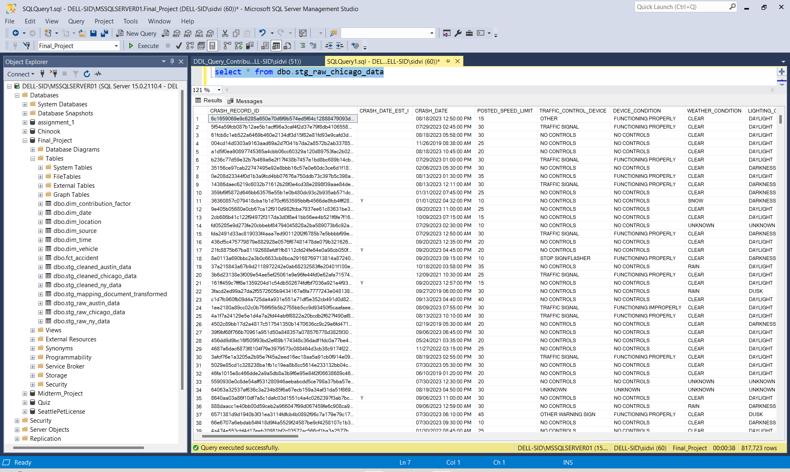

1. NYC Data:

